U.S. Postage

Paid

Minoa, NY 13116

Permit No. 34

*Minoa News*

**Event Issue 2021**

**Volume 18, Issue 2**

Serving the People of Minoa for over 17 years

**Mayor**

William F. Brazill

**Deputy Mayor**

John H. Champagne

**Trustees**

John M. Abbott

Eric S. Christensen

Bobby Schepp

**Clerk-Treasurer**

Lisa L. DeVona

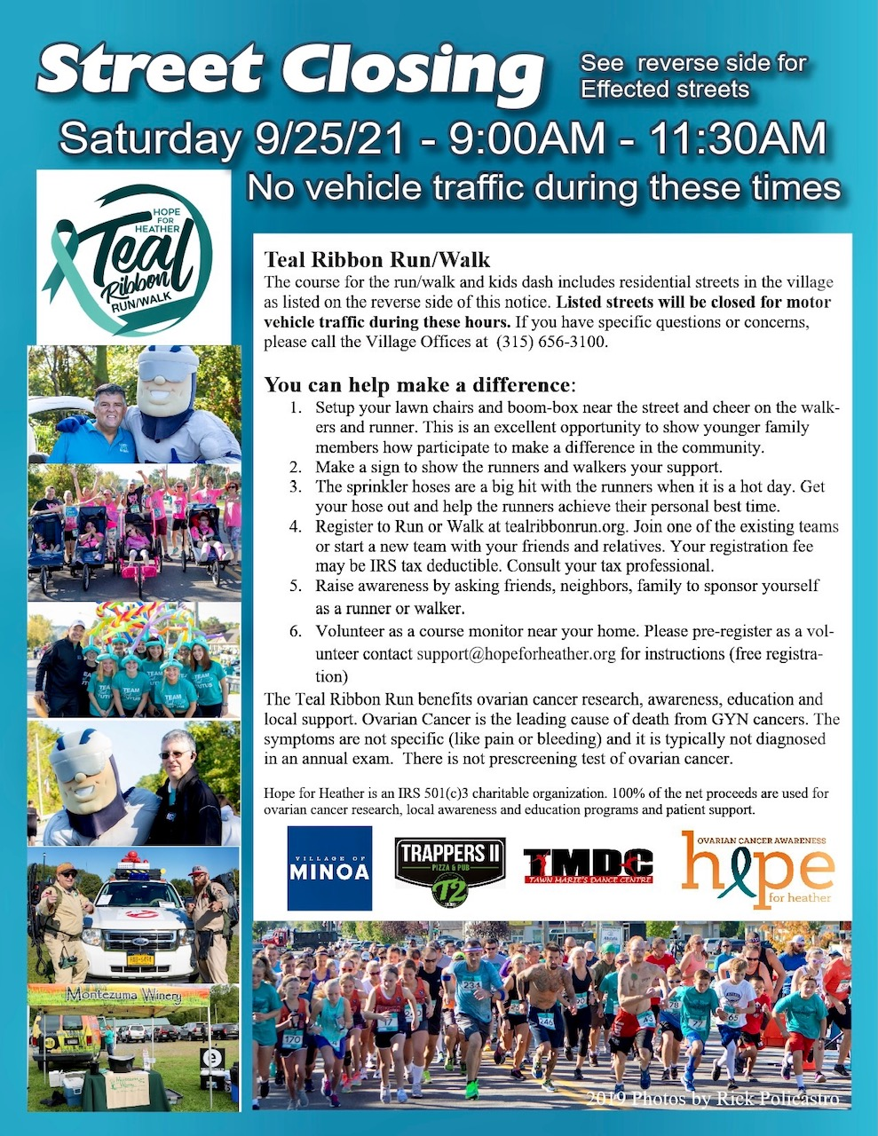

*VILLAGE OF MINOA MEMORIAL MARCH*

***SATURDAY 9/11/21, 8:30AM***

***(from Lewis Park to the Minoa Municipal Building) MARCH FEATURING,***

***FIRST RESPONDERS FROM THE AREA***

***AND THE SYRACUSE SCOTTISH PIPE BAND***

Board of Trustees

meet regularly on the

1st and 3rd Monday

of each month at the Municipal Building 6:30pm

**Village Office**

240 N. Main St.

Monday - Friday 8:00am - 3:30pm

(315) 656-3100

(315) 656-0825 fax



@villageofminoa



Village Taxes & Sewer Rent



Village of Minoa

WEB SITE

www.villageofminoa.com

